Chapter 6 Problems

**Problem 7.** In this problem, we explore some of the properties of the CRC. For the ­generator G (=1001) given in Section 6.2.3, answer the following questions.

1. Why can it detect any single bit error in data D?

[Answer]

Without loss of generality, suppose ith bit is flipped, where 0<= i <= d+r-1 and assume that the least significant bit is 0th bit. A single bit error means that the received data is K=D*2r XOR R + 2i. It is clear that if we divide K by G, then the reminder is not zero. In general, if G contains at least two 1’s, then a single bit error can always be detected.

1. Can the above G detect any odd number of bit errors? Why?

[Answer]

The key insight here is that G can be divided by 11 (binary number), but any number of odd number of 1’s cannot be divided by 11. Thus, a sequence (not necessarily contiguous) of odd-number bit errors cannot be divided by 11, thus it cannot be divided by G.

**Problem 8.** In Section 6.3, we provided an outline of the derivation of the efficiency of slotted ALOHA. In this problem we’ll complete the derivation.

1. Recall that when there are N active nodes, the efficiency of slotted ALOHA is Np(1−p)N−1. Find the value of p that maximizes this expression.

[Answer]

$$E\left(p\right)=Np{\left(1-p\right)}^{N-1}$$

$$E^{'\left(p\right)}=N{\left(1-p\right)}^{N-1}-Np\left(N-1\right){\left(1-p\right)}^{N-2}=N{\left(1-p\right)}^{N-2}\left(\left(1-p\right)-p\left(N-1\right)\right)$$

$$E^{'}\left(p\right)=0→p^{*}=\frac{1}{N}$$

1. Using the value of p found in (a), find the efficiency of slotted ALOHA by letting N approach infinity. Hint: (1−1/N)N approaches 1/e as N approaches infinity.

[Answer]

$$E\left(p^{*}\right)=N\frac{1}{N}{\left(1-\frac{1}{N}\right)}^{N-1}={\left(1-\frac{1}{N}\right)}^{N-1}=\frac{{\left(1-\frac{1}{N}\right)}^{N}}{1-\frac{1}{N}}$$

$$\lim_{N→∞}\left(1-\frac{1}{N}\right)=1, \lim_{N→∞}{{\left(1-\frac{1}{N}\right)}^{N}=\frac{1}{e}}$$

$$\lim_{N→∞}{E(p^{*})}=\frac{1}{e}$$

**Problem 11.** Suppose four active nodes—nodes A, B, C and D—are competing for access to a channel using slotted ALOHA. Assume each node has an infinite number of packets to send. Each node attempts to transmit in each slot with probability p. The first slot is numbered slot 1, the second slot is numbered slot 2, and so on.

1. What is the probability that node A succeeds for the first time in slot 5?

[Answer]

p(A) = probability that A succeeds in a slot = p(A transmits, B doesn’t, C doesn’t, D doesn’t) = p(1 – p) (1 – p)(1-p) = p(1 – p)3

p(A succeeds for first time in slot 5) = p(A)(1 – p(A))^4 = (1 – p(1 – p)^3)^4 * p(1 – p)^3

1. What is the probability that some node (either A, B, C or D) succeeds in slot 4?

[Answer]

p(A succeeds in slot 4) = p(1-p)^3

p(B succeeds in slot 4) = p(1-p)^3

p(C succeeds in slot 4) = p(1-p)^3

p(D succeeds in slot 4) = p(1-p)^3

p(A or B or C or D succeeds in slot 4) = 4p(1-p)^3

1. What is the probability that the first success occurs in slot 3?

[Answer]

p(some node succeeds in a slot) = 4p(1-p)^3

p(no node succeeds in a slot) = 1 - 4p(1-p)^3

p(first success occurs in slot 3)

= p(no node succeeds in first 2 slots) * p(some node succeeds in 3rd slot)

= (1-4p(1-p)3)^2*4 p(1-p)^3

1. What is the efficiency of this four-node system?

[Answer]

p(success in a slot) =4p(1-p)^3

**Problem 14.** Consider three LANs interconnected by two routers, as shown in Figure 6.33.

1. Assign IP addresses to all of the interfaces. For Subnet 1 use addresses of the form 192.168.1.xxx; for Subnet 2 uses addresses of the form 192.168.2.xxx; and for Subnet 3 use addresses of the form 192.168.3.xxx.
2. Assign MAC addresses to all of the adapters.

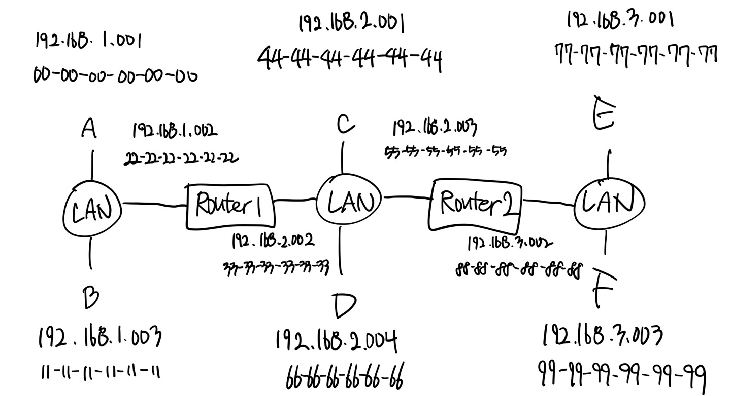

1. Consider sending an IP datagram from Host E to Host B. Suppose all of the ARP tables are up to date. Enumerate all the steps, as done for the single-router example in Section 6.4.1.

[Answer]

Forwarding table in E determines that the datagram should be routed to interface 192.168.3.002.

The adapter in E creates and Ethernet packet with Ethernet destination address 88-88-88-88-88-88. Router 2 receives the packet and extracts the datagram. The forwarding table in this router indicates that the datagram is to be routed to 198.162.2.002.

Router 2 then sends the Ethernet packet with the destination address of 33-33-33-33-33-33 and source address of 55-55-55-55-55-55 via its interface with IP address of 198.162.2.003.

The process continues until the packet has reached Host B.

1. Repeat (c), now assuming that the ARP table in the sending host is empty (and the other tables are up to date).

[Answer]

ARP in E must now determine the MAC address of 198.162.3.002. Host E sends out an ARP query packet within a broadcast Ethernet frame. Router 2 receives the query packet and sends to Host E an ARP response packet. This ARP response packet is carried by an Ethernet frame with Ethernet destination address 77-77-77-77-77-77.

**Problem 15.** Consider Figure 6.33 . Now we replace the router between subnets 1 and 2 with a switch S1, and label the router between subnets 2 and 3 as R1.

1. Consider sending an IP datagram from Host E to Host F. Will Host E ask router R1 to help forward the datagram? Why? In the Ethernet frame containing the IP datagram, what are the source and destination IP and MAC addresses?

[Answer]

No. E can check the subnet prefix of Host F’s IP address, and then learn that F is on the same LAN. Thus, E will not send the packet to the default router R1.

Ethernet frame from E to F:

Source IP = E’s IP address , Destination IP = F’s IP address

Source MAC = E’s MAC address , Destination MAC = F’s MAC address

1. Suppose E would like to send an IP datagram to B, and assume that E’s ARP cache does not contain B’s MAC address. Will E perform an ARP query to find B’s MAC address? Why? In the Ethernet frame (containing the IP datagram destined to B) that is delivered to router R1, what are the source and destination IP and MAC addresses?

[Answer]

No, because they are not on the same LAN. E can find this out by checking B’s IP address.

Ethernet frame from E to R1:

Source IP = E’s IP address , Destination IP = B’s IP address

Source MAC = E’s MAC address

Destination MAC = The MAC address of R1’s interface connecting to Subnet 3.

1. Suppose Host A would like to send an IP datagram to Host B, and neither A’s ARP cache contains B’s MAC address nor does B’s ARP cache contain A’s MAC address. Further suppose that the switch S1’s forwarding table contains entries for Host B and router R1 only. Thus, A will broadcast an ARP request message.
2. What actions will switch S1 perform once it receives the ARP request message?

[Answer]

Switch S1 will broadcast the Ethernet frame via both its interfaces as the received ARP frame’s destination address is a broadcast address. And it learns that A resides on Subnet 1 which is connected to S1 at the interface connecting to Subnet 1. And, S1 will update its forwarding table to include an entry for Host A.

1. Will router R1 also receive this ARP request message?

[Answer]

Yes, router R1 also receives this ARP request message, but R1 won’t forward the message to Subnet 3. B won’t send ARP query message asking for A’s MAC address, as this address can be obtained from A’s query message.

1. If so, will R1 forward the message to Subnet 3? Once Host B receives this ARP request message, it will send back to Host A an ARP response message. But will it send an ARP query message to ask for A’s MAC address? Why?

[Answer]

B won’t send ARP query message asking for A’s MAC address, as this address can

be obtained from A’s query message.

1. What will switch S1 do once it receives an ARP response message from Host B?) [Answer]

Once switch S1 receives B’s response message, it will add an entry for host B in its forwarding table, and then drop the received frame as destination host A is on the same interface as host B (i.e., A and B are on the same LAN segment).

**Problem 21.** Consider Figure 6.33 in problem P14. Provide MAC addresses and IP addresses for the interfaces at Host A, both routers, and Host F. Suppose Host A sends a datagram to Host F. Give the source and destination MAC addresses in the frame encapsulating this IP datagram as the frame is transmitted

1. from A to the left router,

[Answer]

Source MAC address: 00-00-00-00-00-00,

Destination MAC address: 22-22-22-22-22-22

Source IP: 111.111.111.001,

Destination IP: 133.333.333.003

1. from the left router to the right router,

[Answer]

Source MAC address: 33-33-33-33-33-33,

Destination MAC address: 55-55-55-55-55-55

Source IP: 111.111.111.001,

Destination IP: 133.333.333.003

1. from the right router to F.

[Answer]

Source MAC address: 33-33-33-33-33-33,

Destination MAC address: 55-55-55-55-55-55

Source IP: 111.111.111.001,

Destination IP: 133.333.333.003

Problem 26

Let’s consider the operation of a learning switch in the context of a network in which 6 nodes labeled A through F are star connected into an Ethernet switch. Suppose that

1. B sends a frame to E,

[Answer]

Switch learns interface corresponding to MAC address of B. Link packet forwarded to A, C, D, E, F. Since switch table is empty, so switch doesn’t know the interface corresponding to MAC address of E.

1. E replies with a frame to B

[Answer]

Switch learns interface corresponding to MAC address of E. Link packet forwarded to B. Since switch already knows interface corresponding to MAC address of B

1. A sends a frame to B

[Answer]

Switch learns the interface corresponding to MAC address of A. Link packet forwarded to B. Since switch already knows the interface corresponding to MAC address of B

1. B replies with a frame to A.

[Answer]

Switch table state remains the same as before. Link packet forwarded to A. Since switch already knows the interface corresponding to MAC address of A

The switch table is initially empty. Show the state of the switch table before and after each of these events. For each of these events, identify the link(s) on which the transmitted frame will be forwarded, and briefly justify your answers.

Chapter 7 Problems

Please, look at the Figure 7.3 and answer the following questions. Suppose I am using the service whose BER requirement is 10-4.

1. Now SNR = 10 decible. What will be your modulation technique?

[Answer]

BPSK (1 Mbps)

1. Now SNR = 30 decible and QAM256(8Mbps) is used. Since I moved far from AP, SNR dropped from 30 to 20 decible. What will be your modulation technique?

[Answer]

QAM15 (4Mbps)

1. Now SNR = 15 decible(assume that it is middle points between 10 and 20). What is the allowable BER if at least 4Mbps is required for my service?

[Answer]

10^(-2)

**Problem 2.** Consider sender 2 in Figure 7.6 . What is the sender’s output to the channel (before it is added to the signal from sender 1), Zi,m2?

[Answer]

Sender 2 output = [1,-1,1,1,1,-1,1,1]; [ 1,-1,1,1,1,-1,1,1]

**Problem 3.** Suppose that the receiver in Figure 7.6 wanted to receive the data being sent by sender 2. Show (by calculation) that the receiver is indeed able to recover sender 2’s data from the aggregate channel signal by using sender 2’s code.

[Answer]

d^1_2 = 1 , d^2_2 = 1

**Problem 4.** For the two-sender, two-receiver example, give an example of two CDMA codes containing 1 and 21 values that do not allow the two receivers to extract the original transmitted bits from the two CDMA senders.

[Answer]

Sender 1 : (1, 1, 1, -1, 1, -1, -1, -1)

Sender 2 : (1, -1, 1, 1, 1, 1, 1, 1)

Please give 2 reasons why CSMA/CD can’t be used in Wireless LAN.

[Answer]

- Signal attenuation: If B, A hear each other and B, C hear each other, A, C cannot hear each other interfering at B.

- Hidden terminal problem: B, A hear each other, B, C hear each other and A, C cannot hear each other this situation means A, C unaware of their interference at B.

CSMA/CD can’t be used in wireless environments because it relies on the ability to detect collisions, which is difficult in wireless communication due to 2 reasons above to sense the channel while transmitting.

4. What is the reason why CSMA/CA allows collision.

[Answer]

It is because it uses a method of collision avoidance by sending small reservation packets(RTS / CTS). However, collisions can still occur if two nodes transmit their RTS packets simultaneously. The collisions are then resolved through backoff and retransmission mechanisms.